WELSH BACCALAUREATE
Advanced

Community Challenge
Digital Communities Wales

Available for assessment from January 2017

Helping people get online within the community

PURPOSE

The purpose of the Community Challenge is to develop learners’ skills, whilst encouraging learners to identify, develop and participate in opportunities that will benefit a community. During the Community Challenge learners will explicitly develop skills of Planning and Organisation and Personal Effectiveness and apply them in an appropriate manner.

BRIEF
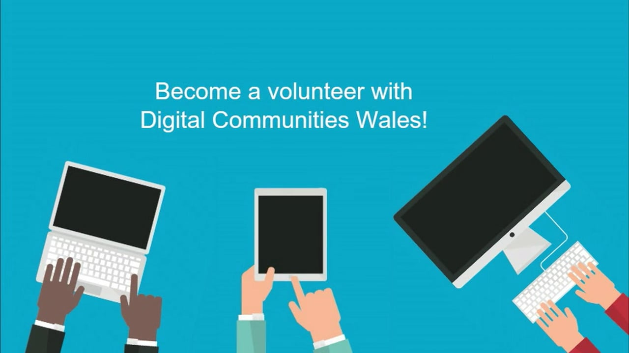
Digital Communities Wales is a Welsh Government digital inclusion programme delivered by the Wales Co-operative Centre. With just under 500,000 people not regularly using the internet in Wales, there is a considerable challenge in reaching people and encouraging them to give it a go. The aim of the Digital Communities Wales Community Challenge is to encourage young people who are digital natives and comfortable with the use of technology, to pass on their skills to support and encourage the thousands of people in Wales who are offline to enter the digital world.

You will be expected to identify opportunities to deliver digital sessions that will help people get online for the first time or help them do something more with technology. You will undertake ‘Digital Heroes’ training to support the delivery of your community activities. This will develop your support skills to help others to get online, develop effective communication skills and help you understand health and safety procedures and complete risk assessment where relevant. Once you've undertaken the training, you will then be responsible for researching the needs of your community, arranging a suitable venue, marketing the activities and ensuring the efficient running of the sessions. Resources will be made available to you through the Digital Communities Wales website.

You must actively engage and demonstrate commitment over a minimum of 30 hours and at least 4 weeks to run these activities and opportunities to get people online.

Resources
Digital Communities Wales

Contact
Marc Davies
Phone: 07766 501904
e-mail: marc.davies@wales.coop

