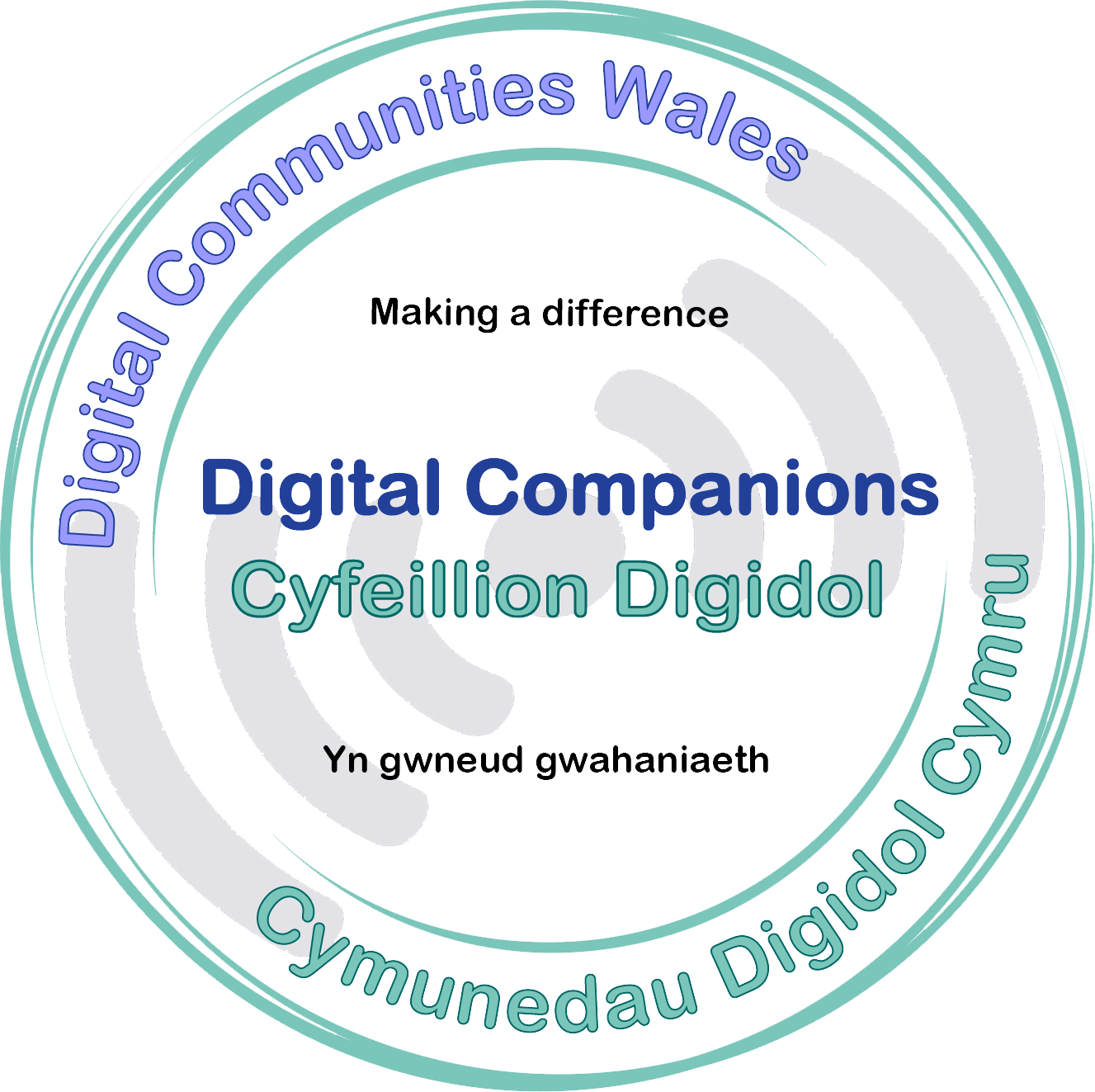
Course Title: Digital Companions
Subject: Information, Communication and Technology (ICT)
Topic: Digital companions
Session duration: 2 Hours

Course Overview
This workshop enables the learners to understand the benefits of being online and being a daily user of technology. The session calls for the good will of the digitally included to support memebers of their community to get online, the workshop will provides the tools to be able to use their own digital skills to help others who are not able to benefit from being online.
During this course the learners will cover safety for the end users and themselves. We will also cover the skills and confidence to teach and to know when to signpost the people they are supporting to more appropriate channels of support.

Entry Requirements
- All participants must have good competency in IT skills.
- Delivery of this course is through digital methods so it is essential participants are able to engage fully with this process.
- Access to a range of websites and digital tools will be needed.

Learning Outcomes
At the end of the session learners will have:

- An understanding of why people are not online
- Understanding how to be safe online
- Essential attributes required to be a successful Digital Companion
- Examples of what people may require help with

Example Tasks:
Within this course learners will have an opportunity to work with each-other to develop and test their communication skills. Activities include working as pairs to discover and research personal interests using our ‘Companion cards’, to practice communication.

